

*[INSERT TII Ref. No.]*

N99 Ballysample

Realignment Scheme

Sample Design Report

Date: xx/xx/20xx

Local Authority Logo & Technical Advisor Logo

Contents

1 Introduction 5

2 Collision History 5

3 Scheme/Safety Objectives 5

4 Existing Conditions 6

4.1 Speed 6

4.2 Traffic Volumes 6

4.3 Horizontal Alignment 6

4.4 Vertical Alignment 6

4.5 Cross Section Crossfall & Superelevation 6

4.5.1 Cross Section 6

4.5.2 Crossfall 6

4.5.3 Superelevation 7

4.6 Junctions & Accesses 7

4.7 Facilities for Vulnerable Road Users 7

4.8 Visibility & Sightlines 7

5 Environmental, Archaeological and Other Constraints 7

5.1 Appropriate Assessment 7

5.2 Ecological Assessment 7

5.3 Other Environmental Surveys 7

5.4 Archaeological Constraints 8

6 Proposed Design 8

6.1 General 8

6.2 Land Acquisition 8

6.3 Horizontal Alignment 8

6.4 Vertical Alignment 8

6.5 Cross Section Crossfall & Superelevation. 9

6.5.1 Cross Section 9

6.5.2 Crossfall 9

6.5.3 Superelevation 9

6.6 Facilities for Vulnerable Road Users 9

6.7 Junctions 9

6.8 Visibility and Sightlines 9

6.9 Drainage 10

6.10 Pavement 10

6.11 Safety Barrier Risk Assessment and Provision 10

6.12 Traffic Signs and Road Markings 11

6.13 Accommodation Works 11

6.14 Lighting 11

6.15 Departures from Standard 11

7 Road Safety Audit 12

8 Total Scheme Budget 12

9 Project Appraisal Balance Sheet 12

Appendix A – Design Drawings i

Appendix B –Road Safety Audit ii

Appendix C – Cost Estimate iii

Appendix D – PABS v

Appendix E - Departures from Standard vii

# Introduction

[Insert a description of the scheme, the scheme objective and previous approvals including Gateway 1 Approval, Some Local Improvement Schemes will not have gone through Gateway Approval if they are not funded by TII]

e.g. The proposed scheme is located approximately 4km north of Ballysample on the N99. The scheme is approximately 1km long and involves the reconstruction of existing sections of the N99 as well as offline realignment to improve sections of sub-standard alignment. The existing alignment has a sub-standard cross section and there are no overtaking opportunities. The scheme was identified as a Type A (High Collision Location) RSIS scheme and received Gateway Approval 1 in accordance with TII Publication GE-STY-01037 in January 2021. The preferred option in the Feasibility and Options Report (Report reference XXX) has been designed in accordance with the relevant standards. This report has been prepared in accordance with the guidance provided in TII PublicationDN-GEO-03030 and approval is sought to proceed to Phase 4, Statutory Procedures.

A site location map is provided below.

[INSERT LOCATION MAP]

# Collision History

[Insert details of any additional collision analysis carried out post-production of the Feasibility and Options Report, if any. For schemes that are not being funded by TII and that have not gone through the Feasibility and Options stage a review of the collision history and analysis thereof will be required in this section.]

Since the production of the Feasibility and Options Report TII have published the results of the latest Network Safety Analysis review as set out in GE-STY-01022. This analysis covers the period 2017 to 2019. The analysis shows that two of the sections of the network in this scheme N99XX_073.0 and N99XX_074.0 have collision rates of twice above the national average. This is consistent with the two previous iterations of the analysis as detailed in the Feasibility & Options Report. Head-on collisions continue to be a problem due to the lack of overtaking opportunities.

# Scheme/Safety Objectives

[Insert both the scheme and safety objectives of the scheme, there may be more than one objective, always consider vulnerable road users]

The primary objectives of the scheme are identified below;

* Provide an improved section of road that is ‘fit for purpose’ for contemporary needs and is consistent with contemporary design standards.
* Provide a standard of road between the locally important towns of Ballysample and Ballysampletwo which will contribute to the development and growth of the towns.
* To improve the safety standards and reduce collision risks by developing a design to contemporary standards including improving and standardising direct private accesses, providing a forgiving roadside, and providing appropriate safety systems where required.
* To provide safer and more efficient accessibility to the N99 route for the local community accommodated along this section and to minimise disturbance and severance impacts to both residential and agricultural holdings.
* To improve facilities for vulnerable road users (longer term).
* To provide suitable overtaking opportunities to avoid overtaking taking place at other unsuitable locations.

# Existing Conditions

## Speed

[Include details of speed limit and actual speed, operational speed maps may be available from TII]

The posted speed limit at this section of the N99 is 80km/hr. The operational speed of this section of the network is 86km/hr.

A design speed calculation was also carried out based on the procedure set out in Section 1 of DN-GEO-03031. The section of the N99 examined was taken from appoint 2km outside the tie-in points.

The measured Bendiness was 77.9 deg/km.

The average verge width was calculated at 1.0m

The VISI value was 201.93m.

Th Layout constraint was determined to be 28 and

The Design Speed of 85km/hr was established.

A speed and traffic count survey were undertaken by TII in 2018 at the R999 junction 1.5 km north of the scheme and the 85th percentile speed was shown to be 86km/hr which is consistent with the calculation.

## Traffic Volumes

[Insert details relating to existing traffic volumes]

The AADT of the N99 was 4,750 in 2019 with an HGV % of 7.4%. This information was extracted from the TII counter website.[www.nratrafficdata.ie](http://www.nratrafficdata.ie). TMU N99 075.N is located approximately 1km north of the scheme.

## Horizontal Alignment

[Include details of the horizontal alignment]

The existing N99 horizontal geometry has a number of horizontal radii that re sub-standard for a design speed of 85km/hr.

## Vertical Alignment

[Include details of the vertical alignment]

The N99 has a number of vertical curves that have crest and sag ‘k’ values that do not meet the requirements of a design speed of 85km/hr.

## Cross Section Crossfall & Superelevation

[Insert any relevant cross-sectional details, typical existing cross section details may be preproduced from the design drawings]

### Cross Section

The existing cross section of the N99 varies along this section. The carriageway varied from 5.9 m to 6.3m wide with no hard shoulders and verge width varying from 0.5m to 1.2m. There are edge of carriageway road markings but without a hard strip. The width between the edge of carriageway markings is as low as 5.7m at some locations.

### Crossfall

[Insert details relating to crossfall]

The crossfall on the N99 varies from 1.5% to 3% on areas where normal camber (2.5%) would be expected.

### Superelevation

[Insert details relating to superelevation]

There is some nominal superelevation at the tighter horizontal bends, it is not developed consistently and varies from 2% to 5.5% in an inconsistent manner.

## Junctions & Accesses

There are a number of existing agricultural and domestic accesses which are located along this section of the N99 which are to be rationalised and maintained. There are no sideroad junctions in this scheme.

## Facilities for Vulnerable Road Users

[Describe existing facilities for vulnerable road users]

This is a rural section of the N99, there are currently no dedicated facilities for pedestrians or cyclists. Pedestrians and cyclists have to use the carriageway as there is no hard shoulder or hard strips and the verge is uneven and narrow. The only places for refuge for pedestrians are private accesses.

## Visibility & Sightlines

[Insert details relating to visibility and sightlines]

Forward visibility is limited due to the horizontal and vertical curves. There are no opportunities for overtaking and it is prohibited by the use of a solid centre line. The stopping sight distance is as low as 60m at some sections which would equate to a design speed of 42km/hr. Sightlines from private accesses are limited due to the alignment and the vegetation at the road edge. Some are as low as 20m which is hazardous for access users and mainline users.

# Environmental, Archaeological and Other Constraints

## Appropriate Assessment

[Insert details of Appropriate Assessment carried out, it is not necessary to append the entire reports however pertinent information leading to design constraints should be included.]

A report for the purposes of Appropriate Assessment Screening was carried out for the Project by [insert entity and report reference]. It was the view of the Author that it the proposed scheme would have no significant impacts on the surrounding environment. An Appropriate Assessment screening decision was made by the Local Authority and it is not necessary to undertake any further stage of the Appropriate Assessment process.

## Ecological Assessment

The proposed scheme will have no direct impacts on any Special Protection Areas or Special Areas of Conservation identified in the Local Authority Development Plan.

## Other Environmental Surveys

[Insert details of any other environmental surveys e.g. mammal surveys, fish surveys, bird surveys agronomy assessments etc.]

Due to the proximity of the existing and proposed N99 it is anticipated that the impact of the scheme on air quality will be negligible.

## Archaeological Constraints

An archaeological assessment to assess whether there is potential for significant archaeological or cultural heritage impacts by the proposed scheme has been carried out by a TII Project Archaeologist. A number of archaeological mitigation measures are proposed for the construction phase. Based on the available information, it is anticipated that the proposed scheme will have no direct impacts on archaeological sites.

# Proposed Design

## General

[Provide a general description of the proposed design, for schemes that have not been funded by TII there may not have been a Feasibility & Options Report prepared and in such cases all options considered must be discussed in this section including a discussion on the options ranking and the choice of the preferred option.]

At the Feasibility and Options Stage/Gateway 1 Approval 6 options were presented including The Do-Nothing option and the Do-Minimum Option. Of the 4 Do-Something Options, Option D was presented as the preferred option and was successful at getting Gateway 1 approval.

The proposed design is to provide a Type 2 single carriageway as per DN-GEO-03036 and CC-SCD-00002. This consists of 2x3.5m lanes 0.5m hard strips and verges on both sides. The realignment will be a combination of on-line and off-line. The off line section will maintain access to a number of existing domestic properties. Facilities for vulnerable road users will not be provided further to an assessment of the N99 north and south of the scheme. This is subject to a Departure from Standard. A wide verge will be provided on the western side to accommodate a future footpath/cycle track if a retrofit scheme is being progressed along the N99 over a distance longer than this scheme. At the tie-in points a reduced and tapering tie -in is proposed. A Departure from Standard has also been prepared for that.

## Land Acquisition

Land acquisition will be required for the off line section and widening of some areas along the on-line section. The land to be acquired will be a combination of the front gardens of domestic houses and agricultural land. A portion of a farmyard will be required close to the northern tie-in. Accommodation works will be required at each domestic and agricultural property.

## Horizontal Alignment

[Description of the range of horizontal curvature etc and highlighting any elements that feature in Departures from Standards]

The horizontal alignment has 2 no. 510m radii with transitions which meet the relaxed lengths allowed for in DN-GEO-03031. There is also a substantial straight at the southern tie in which provides for an overtaking opportunity in both directions and is 55% of the overall scheme length.

## Vertical Alignment

[Description of the range of vertical curvature etc and highlighting any elements that feature in Departures from Standards]

The vertical alignment will have curves that meet the minimum criteria for the design speed. Over such a short scheme it was difficult to maintain a cut fill balance and an import of approximately 175,000m3 is anticipated.

## Cross Section Crossfall & Superelevation.

### Cross Section

[Describe the cross section(s) and provide typical cross section details from the design drawings, describe any changes in the cross sections from the standard construction details]

The cross section is to be as per Table 4.2 of DN-GEO-03036 (Cross Sections and Headroom) and Standard Construction Detail CC-SCD -00002 for Type 2 single carriageways. The cycle track will be omitted.

At the tie-in points a reduced and tapering tie-in is proposed. A Departure from Standard has also been prepared for this and is Included in Appendix E.

### Crossfall

[Provide a description of proposed crossfalls]

A normal camber of 2.5% will be provided at the straight section and as the default crossfall.

### Superelevation

[Describe any superelevation]

Superelevation of 5% will be applied at the 510m radii curves with suitable transitions.

A flat spot analysis in accordance with Chapter 11 of DN-GEO-03031 was undertaken to check if film depths and flow lengths exceed the limits set out. The summary results of the assessment are provided in the drainage section below.

## Facilities for Vulnerable Road Users

[Describe proposed facilities for vulnerable road users]

The cycle track shown on CC-SCD- 00002 will be omitted. It is felt that the presence of a short section of such facilities may lead to an increase in collisions due to the risk associated with the transition back to on-road facilities at the unimproved sections either side of the scheme. A wide verge will be provided however, to ensure that a retrofit scheme can be accommodated in the future along a longer section of the N99. This decision was based on the recommendation of the Stage 1 Road Safety Audit that was carried out of the preferred option during the Feasibility and Options Stage.

A Departure from Standard has also been prepared for this and is included in Appendix E.

## Junctions

[Provide details of each junction and access along the scheme]

Not Applicable.

## Visibility and Sightlines

[Provide a description on visibility and sightlines achieved]

Full overtaking sight distance has been achieved in both directions along the overtaking section.

Sightlines at each direct domestic access, farm access and field gate have been provided to meet with the requirements of DN-GEO-03060. Gates at direct accesses have been set back to accommodate one vehicle. In the case of agricultural accesses this distance is 10m from the carriageway edge.

## Drainage

[Provide description of road and other drainage features including any approval sought to be sought during Phase 4]

The N99 surface water collection will be provided by a system of either filter drains, kerb and gully (accesses) and over the edge which will discharge at suitable outfall locations.

The drainage system has been designed in accordance with DN-DNG-03022 and incorporates SUDs components in that the filter material in filter drains will trap suspended solids and other contaminants thus reducing downstream pollution risks. Where the carriageway discharges over the edge into ditches or grassed channels, the slow moving flow through the grass channels enhances the sedimentation and adsorption process while conveying surface waters to the outfall locations. This also mimics the existing scenario where over the edge drainage is utilised.

A contributing area analysis for the proposed drainage networks has been undertaken to compare the existing hardstanding area contributing to the catchments with the proposed contributing areas of the catchments. There is only a marginal increase in the level of hardstanding area. Online storage has been provided in the network to ensure that there is no worsening of flow rates up to and including the 1 in 100-year storm. The post development peak discharge rates for the critical 1 in 100-year storm duration event are equivalent to the peak predevelopment discharge rates for the critical 1 in 100-year storm duration event.

|  |  |  |
| --- | --- | --- |
| Network Reference | 1 in 100-year Pre-Development runoff Rate (l/s) | 1 in 100-year Post Development runoff Rate (l/s) |
| Network 1 | 29.08 | 29.83 |
| Network 2 &3 | 355 | 359 |

It is proposed to outfall road drainage in Network 1 to the existing outfall location of the N99 drainage network which discharges into the pond at the southern end of the scheme. Networks 2 and 3, at the northern end of the scheme will outfall to the existing stream following online attenuation using baffles in grass channels. An accidental spillage risk assessment and a HAWRAT analysis has been undertaken for the proposed scheme. There is no requirement for provision of pollution control measures such as spillage containment or petrol/oil interceptors for the proposed scheme.

The DN-GEO-03031 Chapter 11 flat spot analysis shows that the greatest film depth is 1.87mm and no flow path exceeds 60m in length.

## Pavement

[Pavement details to be provided including summary of pavement design]

A site investigation was carried out to determine the existing pavement depth and a FWD survey was carried out to determine the pavement condition. Scrim results and information from the TII Pavement Asset Management System (PAMS) were obtained. As a result of the assessments full depth construction is required in both the online and off line sections. The surfacing course will be HRA which will be consistent with the existing sections north and south of the scheme.

## Safety Barrier Risk Assessment and Provision

[Include Risk Assessment as per Chapter 5 of DN-REQ-03079 if required.]

A risk assessment in accordance with Chapter 5 of DB-REQ-03079 been carried out. The assessment identified the need for safety barriers at a number of locations. The completed risk assessment is contained in Appendix Z. Details are shown on Drawings N99- DR-XX-XX-001-005.

## Traffic Signs and Road Markings

[Include details of proposed signs]

Traffic signs and road markings have been designed in accordance with eth Traffic Signs Manual. There is no provision for directional signs for the extents of the proposed scheme.

## Accommodation Works

[Include details of proposed accommodation works]

Field gates are to be set back. One landholding at the northern end of the scheme will require a cattle crush and gates to be relocated to facilitate the relocated field access. An internal field gate and culvert crossing of a land drain is also to be provided for one landowner which will allow one direct field access to the N99 to be removed.

## Lighting

[Include details of proposals for the provision or removal of lighting]

Not Applicable, no lighting on existing alignment and no lighting proposed.

## Departures from Standard

Two departures from standard have been identified as well as two relaxations from Standard. They are summarised in the following table and the full departure applications are included in Appendix E.

|  |  |  |  |  |
| --- | --- | --- | --- | --- |
| Departure/Relaxation Reference | Location | Type | Details | TII Standard Requirement |
| N99 Relaxation 001 | Ch 675 to Ch 1010 | Geometry | Transition lengths of between 43m and 74m applied to 510m radii | 86m with a q value of 0.3m/sec3 (DN-GEO-03031 for 85km/hr design speed |
| N99 Relaxation 002 | Ch 750 to Ch 695 | Geometry | Relaxation of sag curve to one step below desirable minimum (R=2000m) | Desirable minimum sag curve R=2600m as per DN-GEO-03031 Table 1.3. I step below desirable minimum as per para 4.4.2 |
| N99 Departure 001 | Throughout the scheme | Cross Section | No segregated provision for cyclists and pedestrians | Cycle/Pedestrian facilities shall be provided as part of all Type 2 single carriageways. |
| N99 Departure 002 | Ch 0 to Ch 135 and Chainage 860 to Ch 1010 | Cross Section | At the tie-in locations the verge reduces on the approach lengths from 5.0m and 2.5m to 0.75m at both the northern and southern tie-in points. | Verge and Central reserve  dimensions are minimum values:  any reduction is a departure from  standard (Table 3.2 Note 1, DN  03036) |

# Road Safety Audit

[Summary discussion only required here, final signed report to be contained in an Appendix to this report.]

A Stage 2 Road Safety Audit was carried out in March 2020. A stage 2 road safety audit was deemed appropriate as the level of detail provided at this stage is sufficient and it is not anticipated that the tender drawings will include additional design elements other that those that may arise from the Statutory Processes. If those changes are substantial, then a revised audit will be undertaken. The final, signed report is provided in Appendix B.

Three problems were identified by the Audit Team. Two of the problems related road markings and the third related to the extent of safety barrier. All recommendations were accepted by the Design Team and are incorporated into the design drawings appended to this report. The final audit report has been uploaded to the RSAAS.

# Total Scheme Budget

[the cost estimate from the Feasibility and options report is to be stated along with the revised cost estimate, and a summary of the reasons for changes if any. A detailed breakdown to be provided in an Appendix to this report]

The cost estimate for the scheme in the Feasibility and Options Report approved at Gateway 1 was €3,075,000 including VAT. An updated cost estimate has been prepared and a breakdown of the estimate is provided in Appendix C of this report.

The current cost estimate is €2,959,313 including VAT which represents a 3.7% decrease. The decrease is based on a lower than anticipated land acquisition cost as the alignment has been tweaked from the early design stage to avoid disturbance to 2 existing residential properties.

# Project Appraisal Balance Sheet

[PABS to be contained in an Appendix to this report]

A project appraisal balance sheet has been prepared for this scheme in accordance with the guidance set out in DN-GEO-03030. The PABS is provided in Appendix D. The overall description of the scheme is neutral.

# Appendix A – Design Drawings

# Appendix B –Road Safety Audit

# Appendix C – Cost Estimate

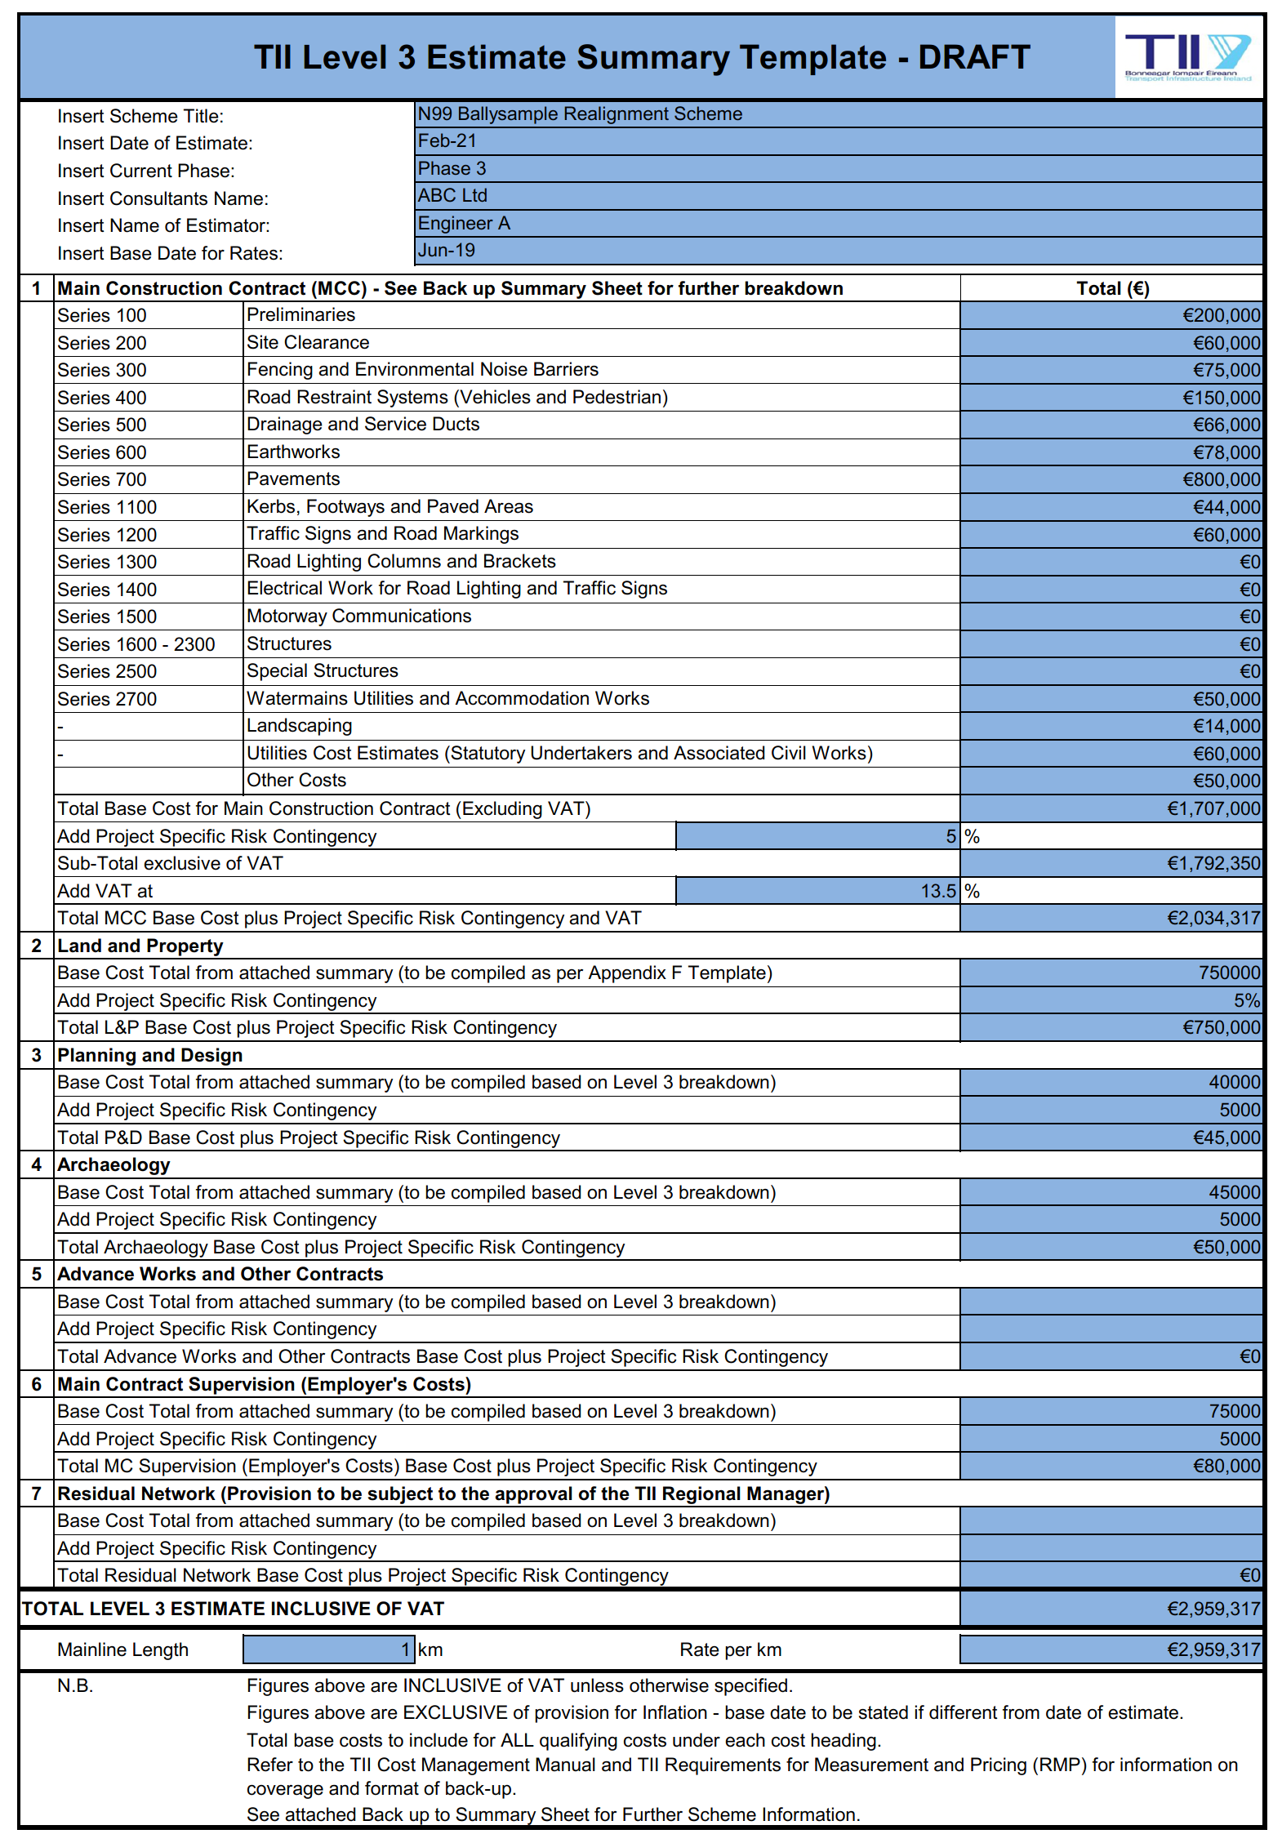

**[Please see TII Publications at** [**https://www.tiipublications.ie/downloads/**](https://www.tiipublications.ie/downloads/) **for work sheets** [**PE-PAG-02021_Unit-6.2-Attachments.zip**](https://www.tiipublications.ie/downloads/project_appraisal_guidelines/PE-PAG-02021_Unit-6.2-Attachments.zip) **that maybe used.]**

# Appendix D – PABS

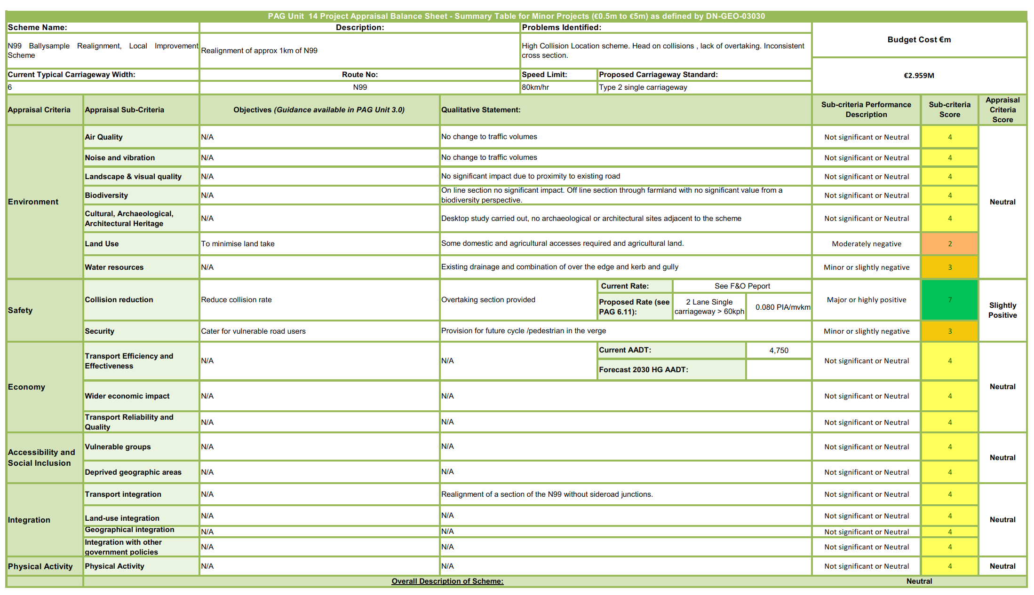

# Appendix E - Departures from Standard

**Application for a Departure from the TII Publications as part of a Preliminary Design Report in accordance with DN-GEO03036**

|  |  |  |
| --- | --- | --- |
| **Application for a Departure from TII Publications (Standards)**  *Includes all documents classified as Standards on*[www.tiipublications.ie](http://www.tiipublications.ie/)*including the Requirements for Measuring and Pricing (RMP)* | | |
| **General Information for Application No. _N99 Relaxation 001_:** | | |
| Route Number: | Scheme: | Contract Type: |
| N99 | Ballysample Realignment Scheme | Employer Designed (Traditional) |
| Design Speed: | Traffic Flow and Composition (if applicable): | |
| _100__ km/h | Approx. _5100______ (Design Year) | |
| Carriageway Type / Road Cross Section: | | |
| Type 2 Single Carriageway | | |
|  | | |
| **Applicant Information:** | | |
| Applicant Name: | Contact Person and Contact Details: | |
| ABC Consulting Engineers Ltd. | Name:  A. Someone  Email:  a@abc.ie | |
| Applicants Departure Reference No: |
| N99 Departure 001 |
| **Departure Information:** | | |
| Departure Location and Chainage *(as relevant):* | | |
| Throughout the scheme, Ch 0 to Ch 1010. | | |
| Publication Stream: | | |
| Geometry (Cross Section) | | |
| Publication: | | |
| DN-GEO-03036 Cross Sections and Headroom | | |
| Publication Paragraph: | | |
| 4.17.1 | | |
| Departure Type: | | |
| Departure for omission of the cycle/pedestrian facilities. | | |
| Standard Required: | | |
| Provision of pedestrian /cycle facilities in accordance with DN-GEO-03047 and CC-SCD-00002 | | |
| Standard Provided: | | |
| No cycle/pedestrian facility provided. | | |
| Justification: | | |
| There are no pedestrian or cycle facilities in the adjacent schemes. The introduction of a short length of a cycle facility could lead to an increase in collisions where the cyclists merge with traffic. It is proposed to provide a widened verge so that a cycle /pedestrian facility can be built in the future if a retrofitting of a longer section of the N99 is undertaken. | | |
| Other Departures or Relaxations at same location: | | |
| N99 Departure 002 – Narrowing of verges on the approached to the tie-in points. | | |
| Additional Information: | | |
|  | | |
| Comments: | | |
|  | | |
| Supporting Documentation: | | |
| Drawing N99-DR-XX-XX-001 | | |
| Status: | | |
| Part of DN-GEO-03030 Design Report submission. | | |

**Application for a Departure from the TII Publications as part of a Preliminary Design Report in accordance with DN-GEO03036**

|  |  |  |
| --- | --- | --- |
| **Application for a Departure from TII Publications (Standards)**  *Includes all documents classified as Standards on*[www.tiipublications.ie](http://www.tiipublications.ie/)*including the Requirements for Measuring and Pricing (RMP)* | | |
| **General Information for Application No. _N99 Relaxation 001_:** | | |
| Route Number: | Scheme: | Contract Type: |
| N99 | Ballysample Realignment Scheme | Employer Designed (Traditional) |
| Design Speed: | Traffic Flow and Composition (if applicable): | |
| _100__ km/h | Approx. _5100______ (Design Year) | |
| Carriageway Type / Road Cross Section: | | |
| Type 2 Single Carriageway | | |
|  | | |
| **Applicant Information:** | | |
| Applicant Name: | Contact Person and Contact Details: | |
| ABC Consulting Engineers Ltd. | Name:  A. Someone  Email:  a@abc.ie | |
| Applicants Departure Reference No: |
| N99 Departure 002 |
| **Departure Information:** | | |
| Departure Location and Chainage *(as relevant):* | | |
| Start and end of the scheme Ch 0 to Ch 135 & Ch 860 to Ch 1010. | | |
| Publication Stream: | | |
| Geometry (Cross Section) | | |
| Publication: | | |
| DN-GEO-03036 Cross Sections and Headroom | | |
| Publication Paragraph: | | |
| Table 4.2 | | |
| Departure Type: | | |
| Departure for a reduction in the required width of the verge for a Type 2 single carriageway at the tie-in points. | | |
| Standard Required: | | |
| 3.0m verge throughout | | |
| Standard Provided: | | |
| Reduction from min. 2.5m (not including hard strip) verge to 0.5m verge | | |
| Justification: | | |
| There are very narrow verges at the tie-in points to gradually introduce the new Type 2 single carriageway cross section it is proposed to widen the verge over approximately 130m. Road narrows signage will be provided. It is believed that the gradual tapering of the verge will prepare drivers for the sections of lower standard road and narrower carriageway either side of eh scheme. | | |
| Other Departures or Relaxations at same location: | | |
| N99 Departure 001 – Omission of cycle/pedestrian facilities. | | |
| Additional Information: | | |
|  | | |
| Comments: | | |
|  | | |
| Supporting Documentation: | | |
| Drawing N99-DR-XX-XX-002 | | |
| Status: | | |
| Part of DN-GEO-03030 Design Report submission. | | |

